**Lab-Project 7: ARP Spoofing with scapy**

**Finding the IP Address of the Windows Machine**

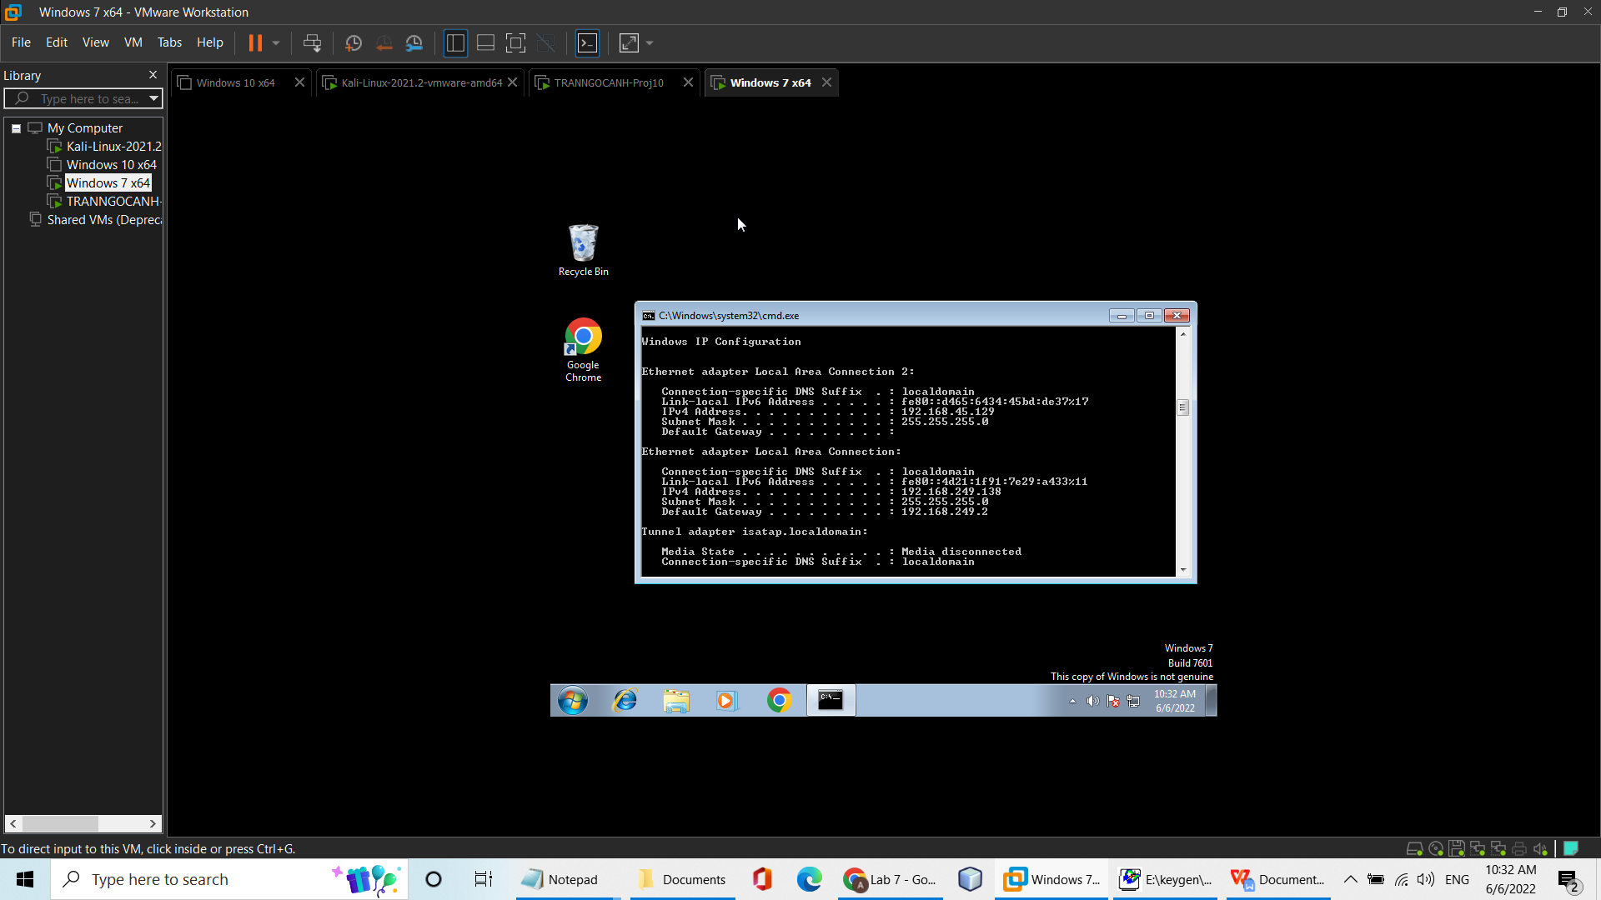

**Clearing the ARP Cache on the Windows Machine**

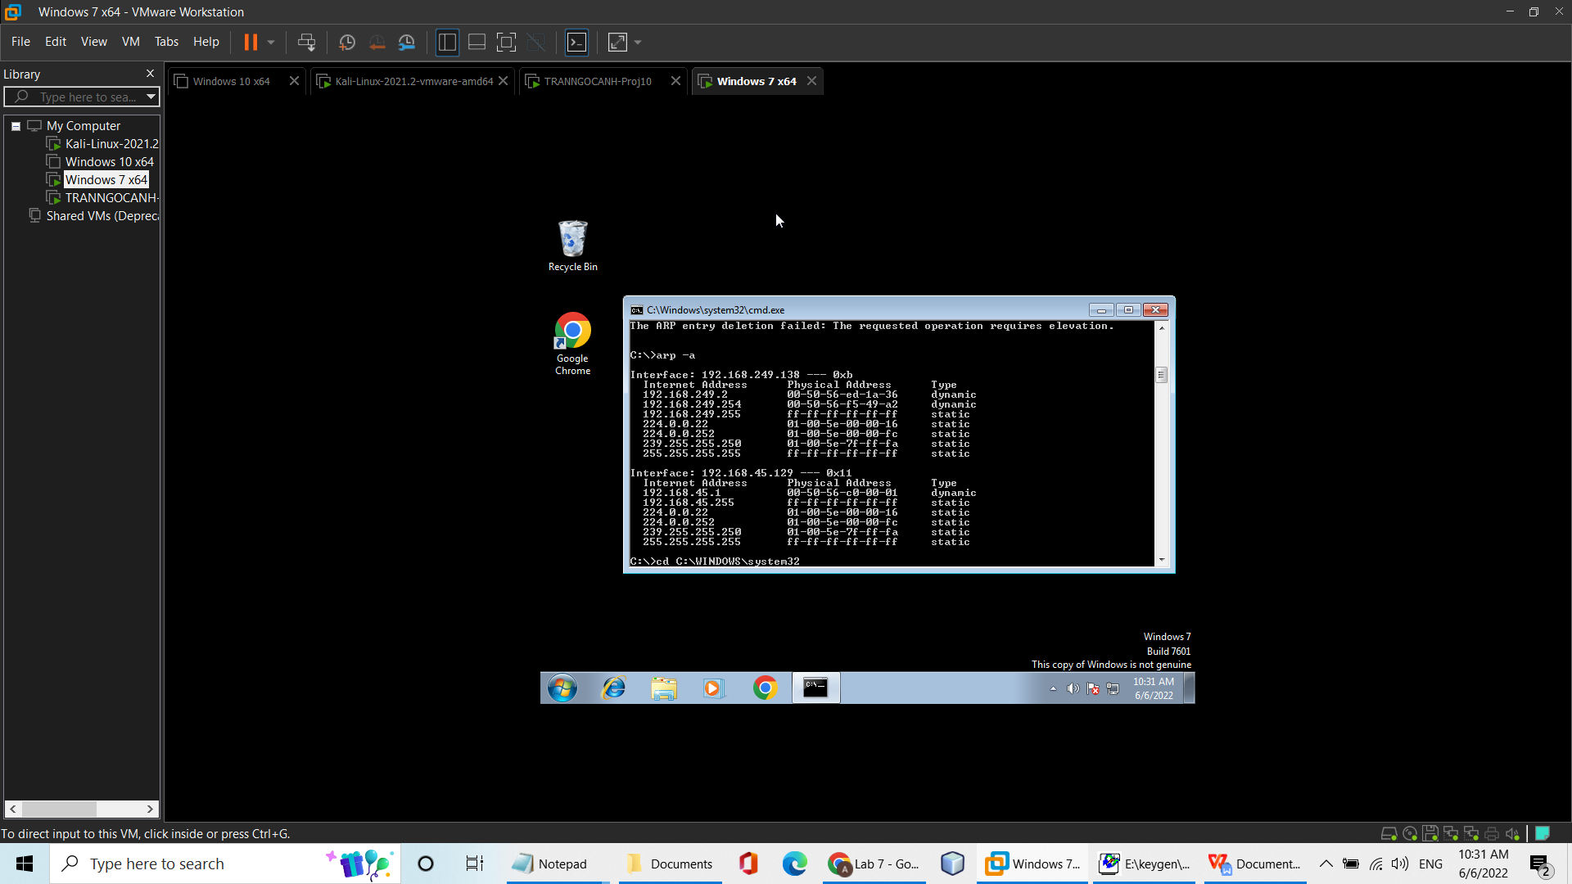

**Sending an ARP from scapy**

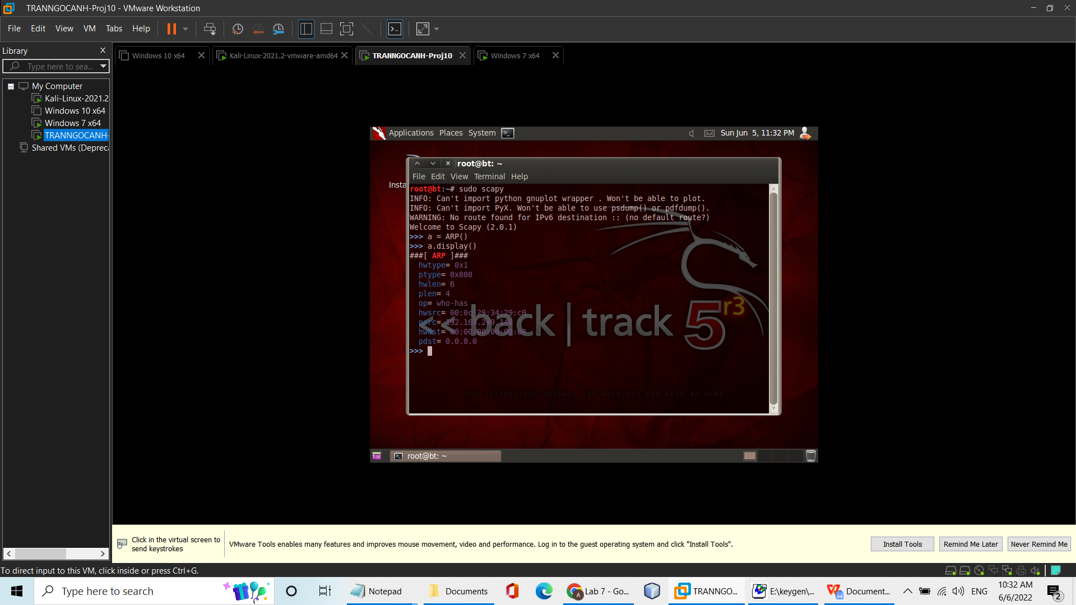

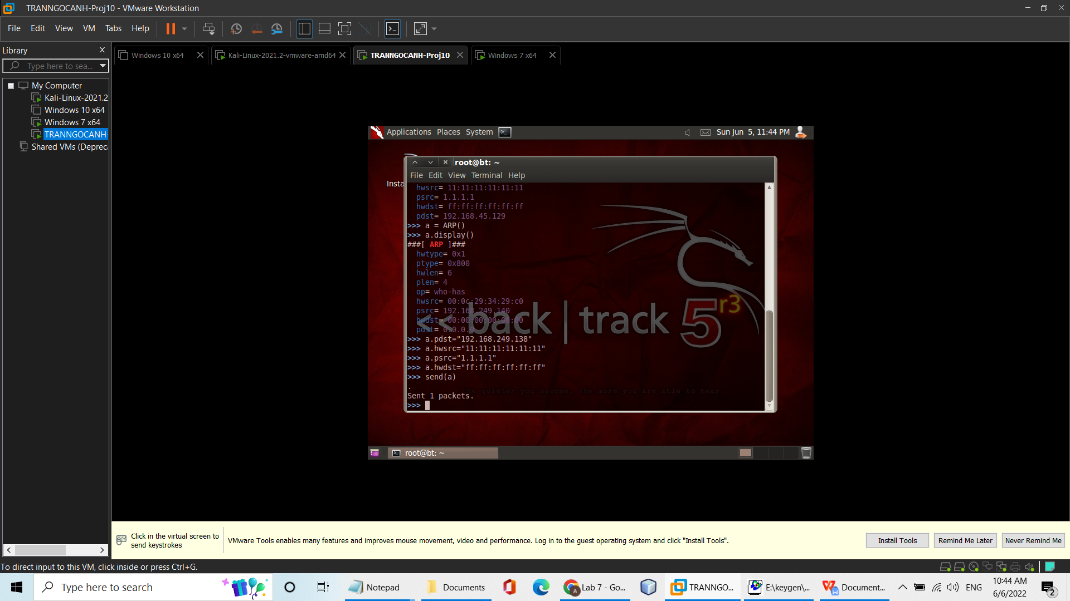

**Viewing the ARP Cache on the Windows Machine**

